NYC Parking Tickets Analysis

ZHICHENG YU, Louis Tan, Nevin Yilmaz
e-mail: zyu4@calstatela.edu/ ltan3@calstatela.edu / nyilmaz@calstatela.edu

Abstract: The study is to show how Big data technology helps us to analyze a large dataset, to practice Hadoop HiveQL SQL-like language to query the dataset and to find out different factors hid behind this NYC packing tickers dataset. Begin with understanding the structure of this dataset, we list all the columns and their data type in a table, which gives us a clear view to continue studying. Then we filter out specified columns and combine them with different query methods, and these results show us different conclusions. Finally, we convert these results to the graphic images, they make these results viewable and clear enough.

1. Introduction
This study is based on a 1.7GB size dataset, all the scripts are running in the IBM cloud or Oracle cloud. Graphic UI and Command line window are both used in this study.

2. General Instructions
IBM Cloud configuration(Nodes: 3 CPU: V4 2.2 GHz, RAM: 16GB HDFS version: 2.7.3 Hive Version 1.2.1000)
Oracle Cloud configuration(Nods: 5, CPU: 2.0 GHz, RAM: 150GB ) 1

2.1 Dataset detail
The NYC Department of Finance collects data on every parking ticket issued (~10M per year!). This data is publicly available to aid in ticket resolution and to guide policymaker in NYC. To summarise the table detail, it was collected between 2012.7 and 2014.7. There are 51 columns and more than 9 million row inside this table. The dataset default format is comma-separated values.

2.2 Workflow
There are main workflows. All of the three gets the same data from kaggle.com, and then upload CSV file either IBM server or Oracle server. When using the IBM server, HiveQL script will be run on the Ambari UI. On the other hand, the Oracle server will provide a command line window. Lastly, there is one local Hadoop server we have used, which is the same as IBM server with Ambati UI. When all queries have done, we download table file and use excel to visualize the results.

2.3 Violation Plates
The first insight we are going to figure out is answering the question which car received the most tickets. Because there are too many columns inside the table, we filter out three main columns, they are plate ID, vehicle type and issued state.

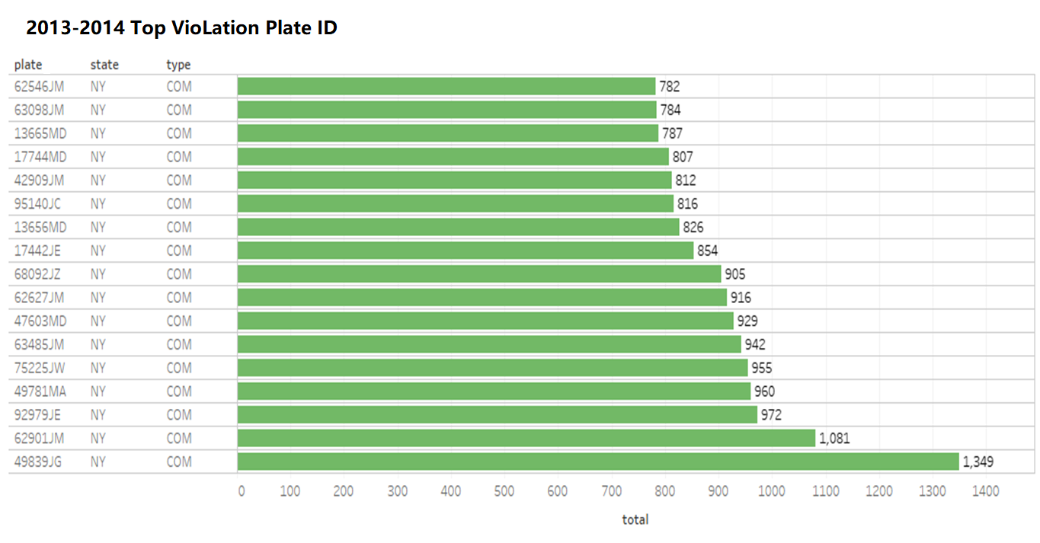
Figure 1. the top number of violation plate ID

2.4 Analysis of the Parking Ticket Seasonality
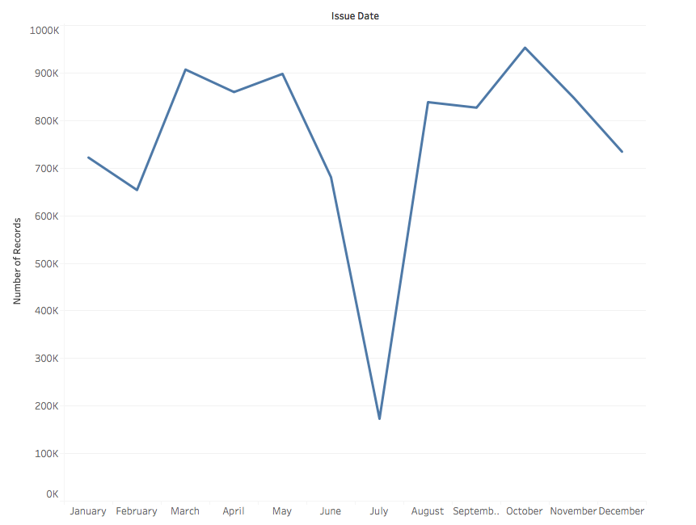
Figure 2. the relationship between tickets volume and month of the year

From Figure 2 we can easily tell that in summer there are fewer tickets assigned. Almost 25% of the peak, which we can easily conclude that parking violation in summer could escape from police officer easier. While, this only proves that there are fewer tickets but not the lower rate of the tickets assignment. We need more proof to establish the relastionship.

Figure 3. New York city air pollution chemicals concentration vs Month of the year

From the graph we can tell that the CO emission is higher in the winter than the summer, and CO is mainly emitted by vehicles. Then we could know there are more cars in the winter than the summer. New York City has complete public transportation system, and, in the summer, people are more inclined to take the bus or subway, but the in the winter, it’s too cold to walk outside.

When we look back at Figure 2, the reason behind it should be the reduction of car amount instead of more friendly police officer. From this analysis, we find the relationship between tickets volume and month of the year and we believe there are not strong relationship between the change of escaping from violation tickets and season.

2.5 Top 4 Violation Codes
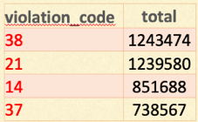

Figure 4. Top 4 violation codes
Figure 4 shows the top 4 violation codes for parking tickets in NYC. Code 37 and 38 represents meter parking with a fee of $65; Code 21 represents street cleaning with a fee of $65; Code 14 represents no parking with a fee of $95.

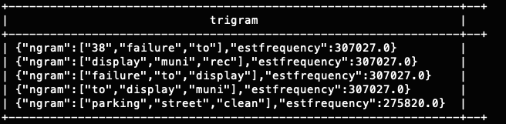
2.6 Ngram: Five Most Common Trigrams
Figure 5. ngram
This figure shows the police officer descriptions for the parking tickets. These are consistent with the violation codes.

2.7 Violation by Car Model
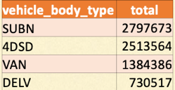

Figure 6. vehicle body type vs. violations
Figure 6 shows that most parking tickets belong to big cars, like big SUVs and 4 door sedan cars

2.8 Violation by Car Make
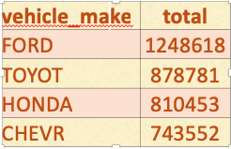

Figure 7. vehicle make vs. violations
Although this table shows that most violations are made by economy cars, such as Ford and Toyota, we cannot make a decision on whether or not people who have economy cars care less compare to people who have luxurious cars. The reason is that we don’t have information on what percentage of cars are economy and what percentage of cars are luxurious. If the majority of cars are economy cars than this result is not because of being careful or not, but because there are not many luxurious cars.

2.9 Violation time trends
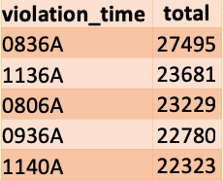

Figure 8. violation times
This table shows that most are the violations are occurred in the morning. We can say that either police officers tend to give tickets more during morning times or people are more in hurry and leave their cars in violation areas.

4. Conclusion
With NYC parking ticket dataset, we tried to answer following questions:
What days were the tickets issued most?
Is there a relationship between having a parking ticket and say, having a big car, like a truck or a small car?
Do people who have newer cars care more than those who have older cars?
Do people who have luxurious cars are more careful on how and where they park their cars?
What are the most common words used?
What are the most common violation types?
Our analysis show that seasonality is important when it comes to parking violations. People got more tickets in winter months than in summer months. We cannot conclude if economy or luxury cars got more tickets without knowing what the distribution of those two cars is. Most common words used in violation descriptions are consistent with the most occurred violation codes, which are meter parking, street cleaning and no parking.

References
[1]https://www.sciencedirect.com/science/article/pii/S1352231018301997)
[2]https://www.nycgo.com/assets/files/pdf/new_york_city_travel_and_tourism_trend_report_2017.pdf
[3] zzato, S., Masiol, M., Rich, D. Q., & Hopke, P. K. (2018). PM 2.5 and gaseous pollutants in New York State during 2005–2016: Spatial variability, temporal trends, and economic influences. Atmospheric Environment, 183, 209-224. doi:10.1016/j.atmosenv.2018.03.045
[4] The Official New York City Guide / nycgo.com. (n.d.). Retrieved from https://www.nycgo.com/

https://cloud.oracle.com/compute/virtual-machine/features
https://www.kaggle.com/new-york-city/nyc-parking- tickets
https://github.com/nyilmaz1/NYC_parking-Hive/blob/master/DOF_Parking_Violation_Codes.csv

